* **Install nodejs**

Download nodejs

<https://nodejs.org/en/download/current/>

**Downloaded File :** node-v8.1.3-x64.msi

C:\Program Files\nodejs\

===========================================

**Open CMD from window run**

**Use cd.. To change directory**

* **Install angular/cli**

c:\>users\vipul>cd..

.

.

c:\> cd G:\angularjs2\project

c:\> G:

G:\> angularjs2\project>npm install -g @angular/cli

**It will install angular cli on nodejs for selected folder**

Now nodeJS will use cli commands for angular by using

**Ng** prefix

ng will be always used at start to run cli command

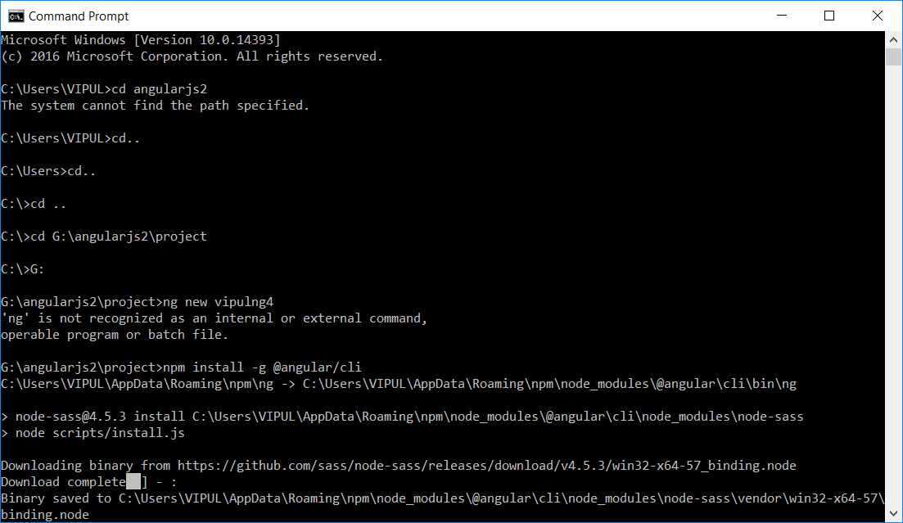

* **Create project folder**

G:\> angularjs2\project>ng new vipulNg4

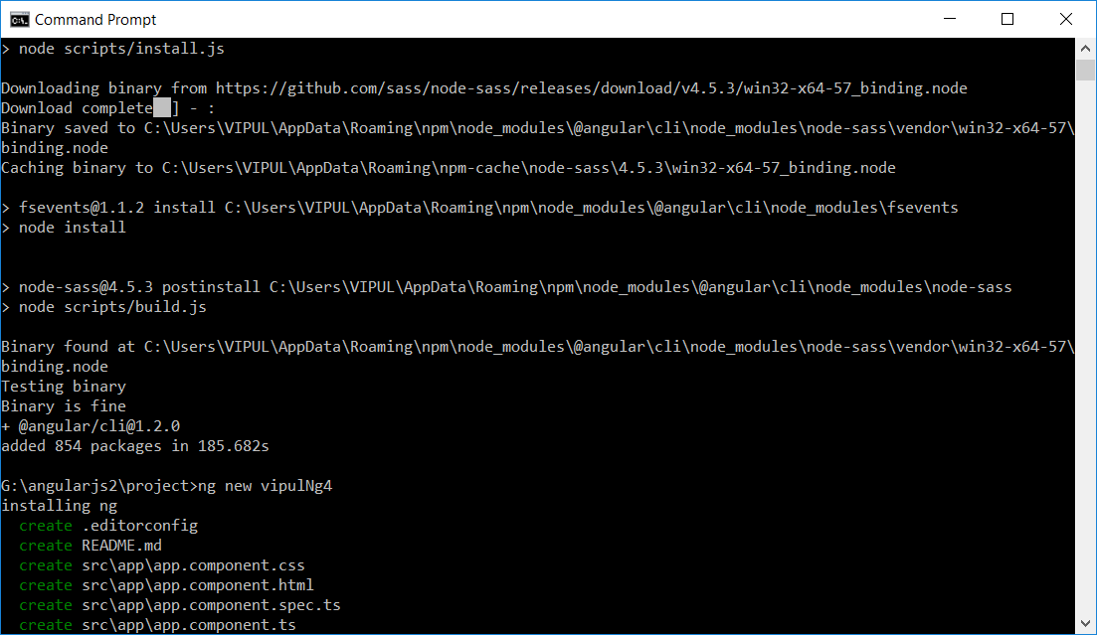

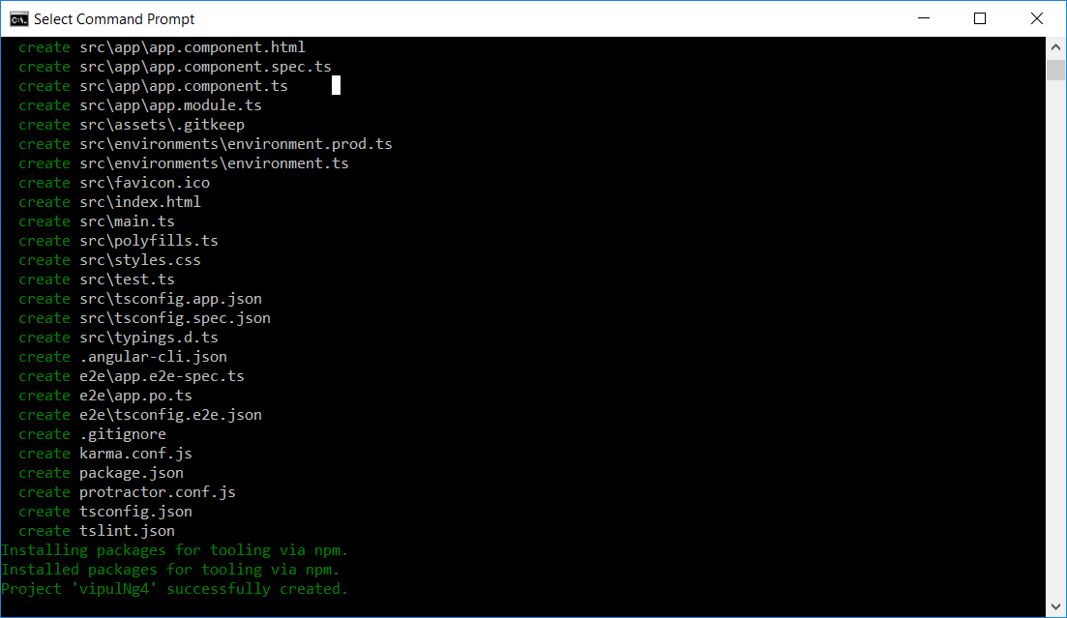

**Check the windows folder everything will be installed**

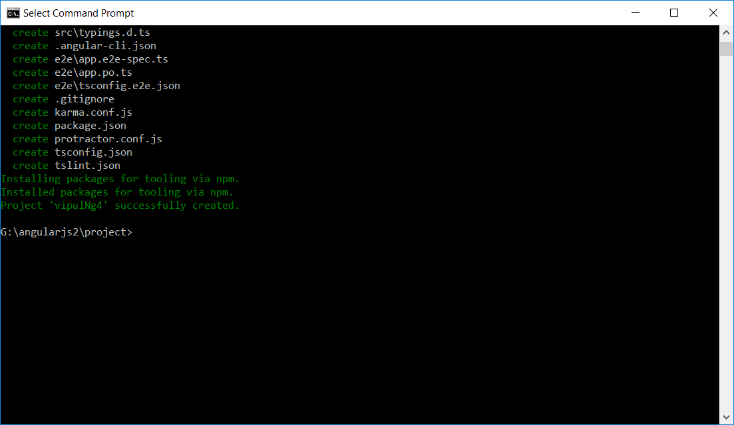

* **Open project cmd**

==================================

goto window folder > file and type 'cmd' once vipulNg4 is created

New cmd with the path will be opened

==================================

G:\> angularjs2\project>vipulNg4>

==================================

Now run command- ng serve

==================================

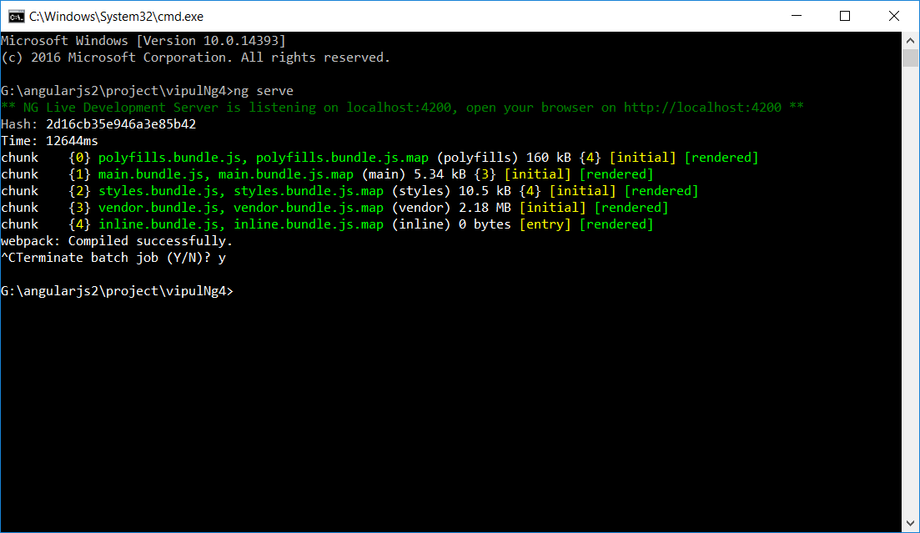

Same you can use vscode > terminal i.e. use cntrl~

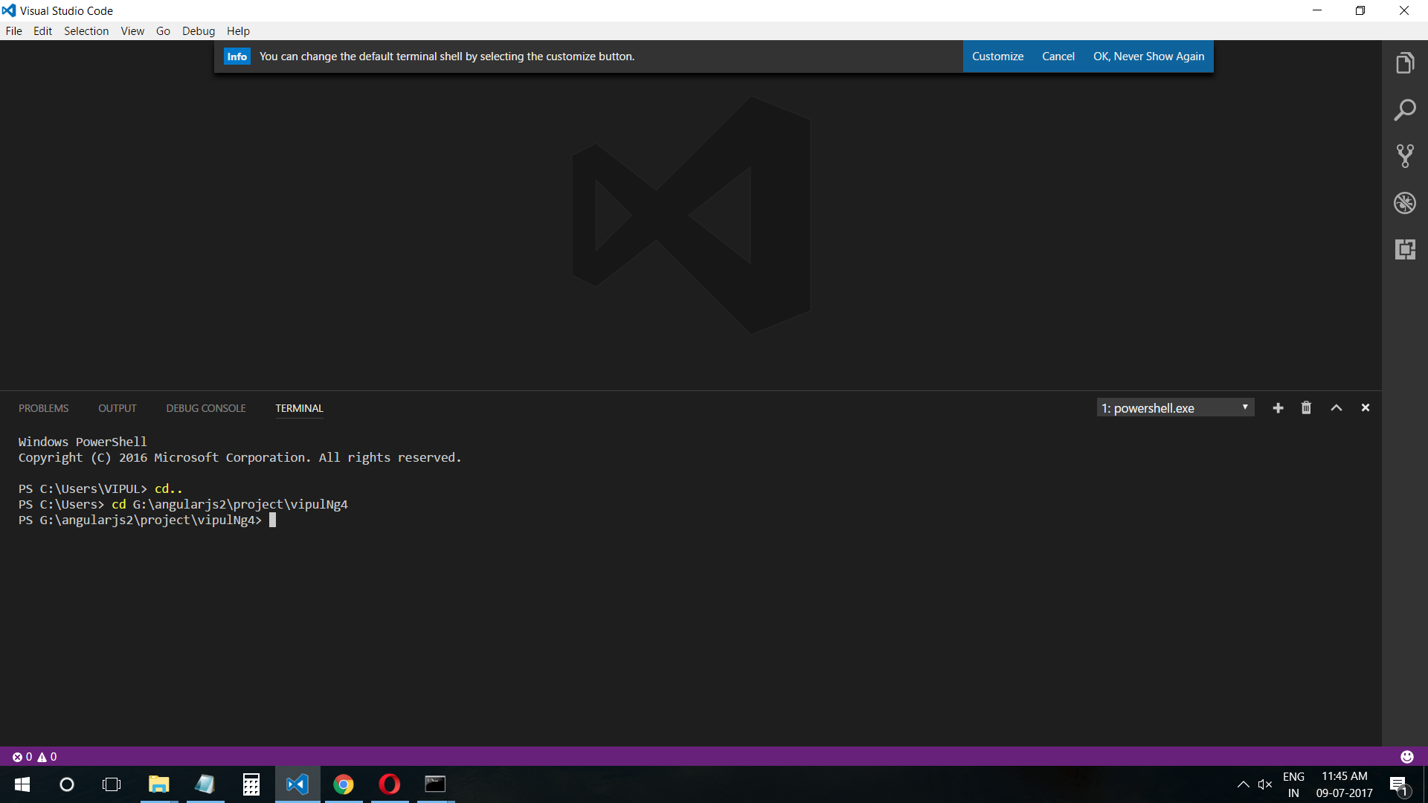

G:\> angularjs2\project>vipulNg4>ng serve

==================================

cmd message

webpack: Compiled successfully.

==================================

* **Now Terminate by cntr c command**

^CTerminate batch job (Y/N)?

**Type ‘y’**

G:\> angularjs2\project>vipulNg4>

* **Now using Terminal - apply same commands as cmd**

G:\> angularjs2\project>vipulNg4>src>app> mkdir components

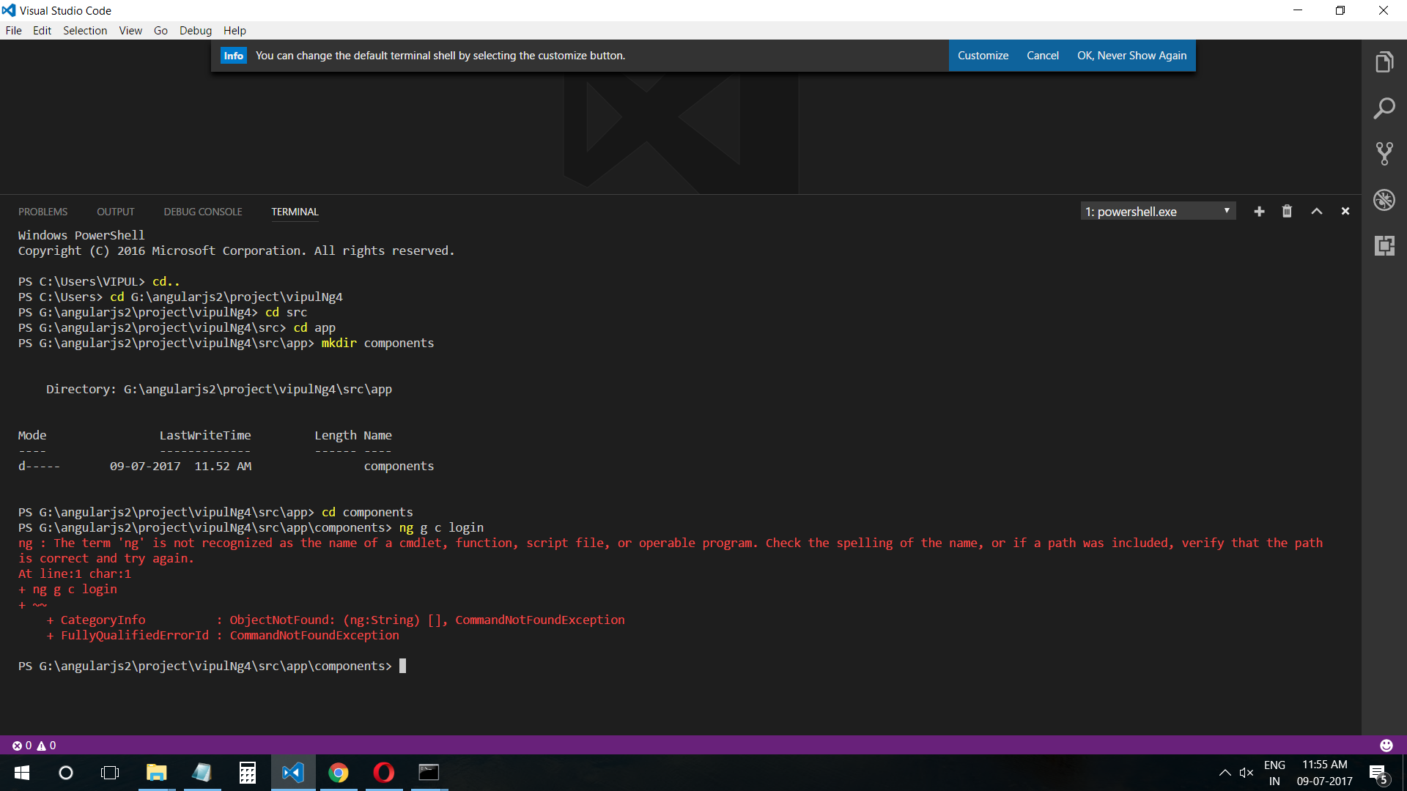

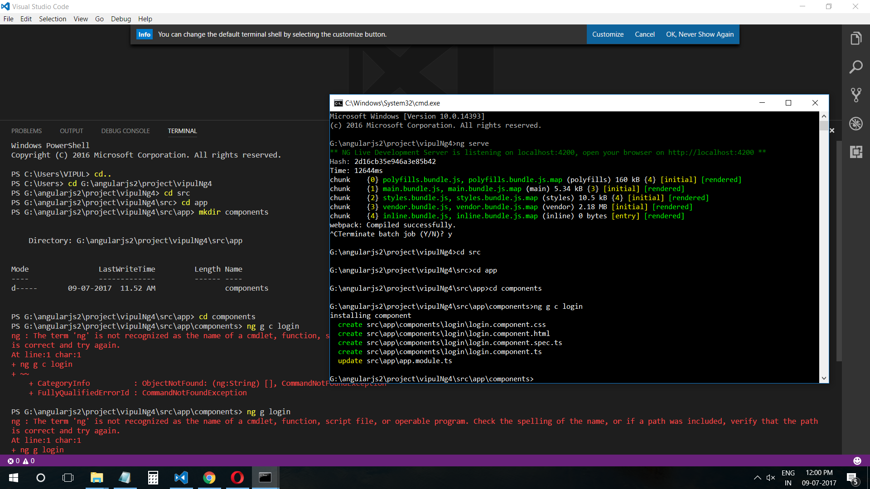

* **Use cmd to create component**

G:\> angularjs2\project>vipulNg4>cd src

G:\> angularjs2\project>vipulNg4>src>cd app

G:\> angularjs2\project>vipulNg4>src>app> mkdir components

G:\> angularjs2\project>vipulNg4>src>app>cd components

G:\> angularjs2\project>vipulNg4>src>app>components>ng g c login

Hence

ng - refrence for angular cli

g - genterate

c - component

<login>

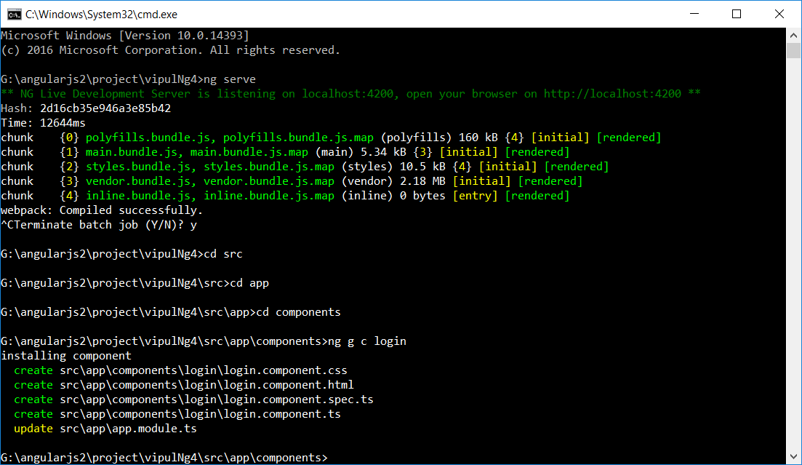

**Every Update should run ng serve .**

G:\> angularjs2\project>vipulNg4>src>app>components>ng serve

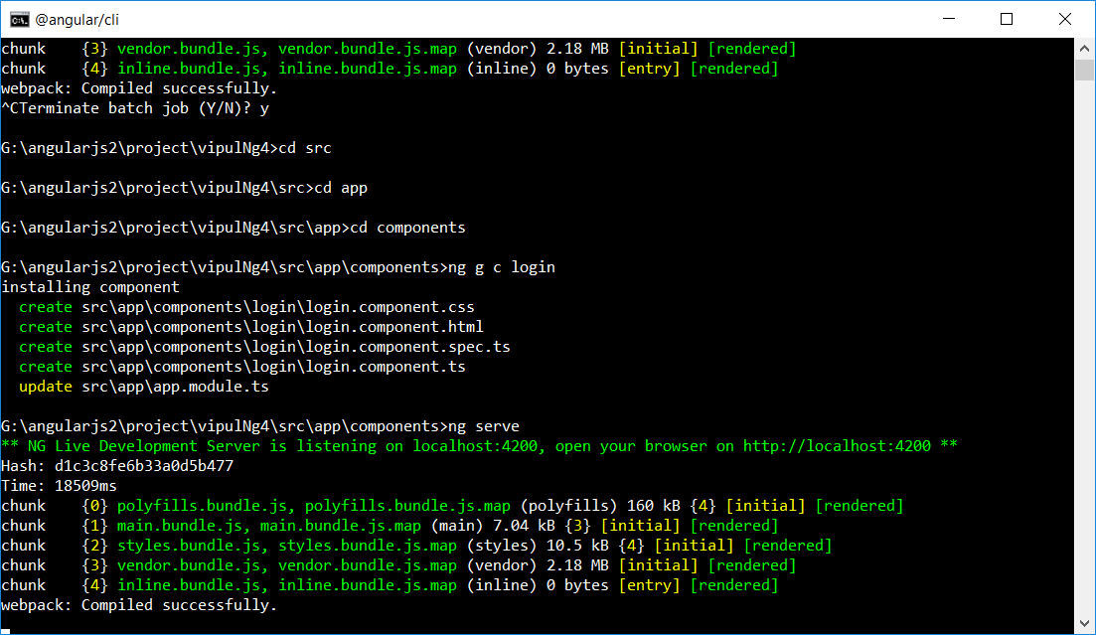

* **Now Terminate by cntr c command**

^CTerminate batch job (Y/N)?

G:\> angularjs2\project>vipulNg4>src>app>components>cd..

* **Use cmd to Install bootstrap library**

G:\> angularjs2\project>vipulNg4>src>app> npm install bootstrap --save

